AAT LAB 3

Name : Swarangi Kothawade
Div/Roll No. : A-34

BINARY SEARCH

#include <iostream>
using namespace std;

int binarySearch(int arr[], int n, int key) {
int low = 0, high = n - 1;

while (low <= high) {
int mid = (low + high) / 2;

if (arr[mid] == key)
return mid;
else if (arr[mid] < key)
low = mid + 1;
else
high = mid - 1;
}

return -1;
}

int main() {
int arr[] = {10, 20, 30, 40, 50};
int n = 5;
int key = 30;

int result = binarySearch(arr, n, key);

if (result != -1)
cout << "Element found at index " << result;
else
cout << "Element not found";

return 0;
}

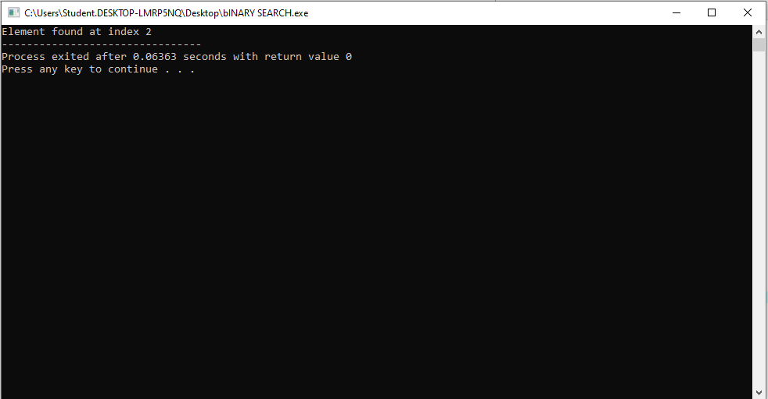

QUICK SORT

#include <iostream>
using namespace std;

int partition(int arr[], int low, int high) {
int pivot = arr[low];
int i = low + 1;
int j = high;

while (i <= j) {
while (i <= high && arr[i] <= pivot)
i++;
while (arr[j] > pivot)
j--;

if (i < j)
swap(arr[i], arr[j]);
}

swap(arr[low], arr[j]);
return j;
}

void quickSort(int arr[], int low, int high) {
if (low < high) {
int p = partition(arr, low, high);
quickSort(arr, low, p - 1);
quickSort(arr, p + 1, high);
}
}

int main() {
int arr[] = {30, 10, 50, 20, 40};
int n = 5;

quickSort(arr, 0, n - 1);

cout << "Sorted array: ";
for (int i = 0; i < n; i++)
cout << arr[i] << " ";

return 0;
}
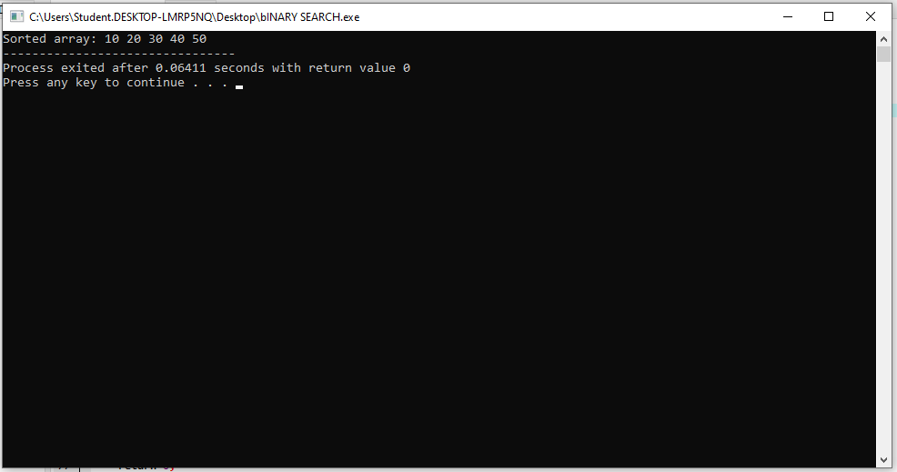

MERGE SORT

#include <iostream>
using namespace std;

void merge(int arr[], int low, int mid, int high) {
int i = low, j = mid + 1, k = low;
int temp[100];

while (i <= mid && j <= high) {
if (arr[i] < arr[j])
temp[k++] = arr[i++];
else
temp[k++] = arr[j++];
}

while (i <= mid)
temp[k++] = arr[i++];

while (j <= high)
temp[k++] = arr[j++];

for (int i = low; i <= high; i++)
arr[i] = temp[i];
}

void mergeSort(int arr[], int low, int high) {
if (low < high) {
int mid = (low + high) / 2;
mergeSort(arr, low, mid);
mergeSort(arr, mid + 1, high);
merge(arr, low, mid, high);
}
}

int main() {
int arr[] = {38, 27, 43, 3, 9, 82, 10};
int n = 7;

mergeSort(arr, 0, n - 1);

cout << "Sorted array: ";
for (int i = 0; i < n; i++)
cout << arr[i] << " ";

return 0;
}
